CPE 431/531 Processor Basics Fall 2022

**The University of Alabama in Huntsville**

**ECE Department**

**CPE 431 01, CPE 531 01/01R**

**Processor Basics**

**Fall 2022**

**Due September 17, 2022**

**1.0 (30)**

**1.0 <4.1>** When processor designers consider a possible improvement to the processor datapath, the decision usually depends on the cost/performance trade-off. In the following three problems, assume that we are starting with the datapath shown, where I Mem, Add, Mux, ALU, Regs, D Mem, and Control blocks have latencies of 320 ps, 150 ps, 20 ps, 180 ps, 90 ps, 350 ps, and 120 ps, respectively, and costs of 900, 80, 10, 195, 250, 1000, and 180, respectively.

Consider the addition of a multiplier to the ALU. This addition will add 250 ps to the latency of the ALU and will add a cost of 450 to the ALU. The result will be 10 % fewer instructions executed since we wil no longer need to emulate the MUL instruction.

* + 1. **<4.1> (15)** What is the clock cycle time with and without this improvement?

Path from PC lower: I-Mem, Registers, Mux, ALU, D-Mem, Mux, (end at reg)

990 ps without improvement

1240 ps with improvement

* + 1. **<4.1> (10)** What is the speedup achieved by adding this improvement?

Given 1000 instructions. 10% is 900.

No improvement: 990000

Improvement: 1116000

Running time decreased: 126000, Slower by 0.887

There is no speedup. The improvement is slower than no improvement by 0.887

* + 1. **<4.1>** **(5)** Compare the cost/performance ratio with and without this improvement.

I-Mem, Reg, 3 Mux, 2 Add, D-Mem, ALU, Control

900, 250, 30, 160, 1000, 195, 180 = 2715

With improvement = 3165

Ratio: cost/performance where performance = 1/ET

No improvement: 2715/1/990ps = 2.688 microseconds

Improvement: 3165/1/1240 ps = 3.925 microseconds

There is no improvement between the cost/performance ratios.

|  |  |  |  |  |  |  |  |
| --- | --- | --- | --- | --- | --- | --- | --- |
|  | I Mem | Add | Mux | ALU | Regs | D Mem | Control |
| Latency | 320 | 150 | 20 | 180 | 90 | 350 | 120 |
| Cost | 900 | 80 | 10 | 195 | 250 | 1000 | 180 |

With Improvement: ALU will be 430 with 645 cost

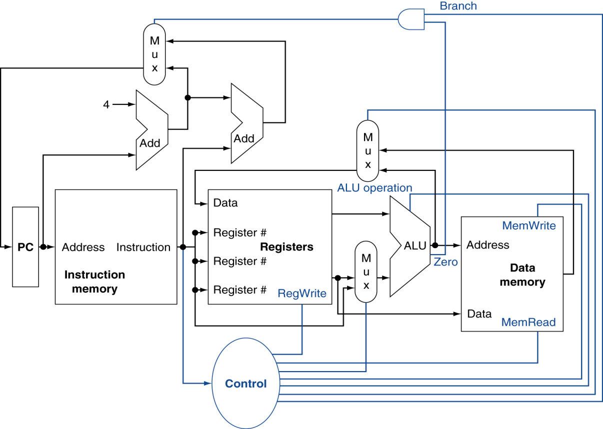



Page 2 of 1